Lab 2-1 Modifying Views
Goals | To modify the results of an analytics request beyond the default format
Scenario | Add a chart to a request and rearrange how the various views within a request are displayed.
Outcome | An analytics request with a chart view
Time | 5 – 10 minutes
Environment | 
Instructions:
- Verify that the PopChart service is started. This is the engine that renders results in chart and graph views in Siebel Answers and Intelligence Dashboards.
  - Select Start > Programs > Administrative Tools > Services.
  - In the Services window, scroll to locate the PopChart 5.1 service.
  - Double-click the PopChart 5.1 service.
  - Verify that Startup type is set to Automatic. If not, change it.
  - Verify that Service status is set to Started. If not, start the service.
  - Click OK.
  - In the Services window, verify that the PopChart 5.1 service is started and Startup type is set to Automatic.
  - Minimize the Services window.
- Click Answers to clear the workspace and navigate to the catalog where saved requests are stored.
- Modify the Sales by State request.
  - Select the saved request, Sales by State, from the catalog.
  - Click Modify.
  - From the SalesFacts folder, add the measures Units Ordered and Units Shipped to the Sales by State request.
  - From the My Filters folder, click the West Region, 1999 filter you created in a previous lab to add it to the request.
  - In the Apply Saved Filters window, click OK.
- Create a chart view.
  - Click the Show results in a chart view button to display the results of the request. The default chart type is Vertical Bar.
  - In the Graph drop-down list, at the top of the screen, select Horizontal Bar.
- Add different facts to the chart.
  - In the vertical axis in the Columns section, uncheck the Dollars fact and select the check boxes for both Units Ordered and Units Shipped.
  - Click the Redraw button (below chart view) and notice the results.
- Change the chart width size by clicking and dragging the horizontal bar at the bottom of the chart two tick marks to the right.
- Verify that the horizontal and vertical axes titles are displayed and create a title for the chart.
  - Click the General Chart Properties button at the top of the screen. The General window opens.
  - Select Custom and type Western Sales 1999 in the field.
  - Click OK.
  - Verify that the title was added to the chart.
- View the results in compound layout.
  - Select Compound Layout from the result view drop-down list.
  - Click the Chart icon to add the chart to the compound layout.
  - If necessary, scroll down to view the chart.
- Change the title view in the compound layout.
  - Scroll up to see the Title view.
  - Select the Edit View button for the Title view.
  - Enter Western Region Sales 1999 in the Title field.
  - Deselect Display Saved Name check box.
  - Click OK in the upper right corner.
  - Verify that the title view is changed.
- Move the views to change the display.
  - Scroll down to the Chart view.
  - Click the Move View Up button on the Chart view.
  - Click the Move View Right button on the Table view.
  - Click the Move View Up button on the Title view.
  - Save the request as Western Region Sales with Chart.
- Notice the results when attempting to save a request using the same name as a saved request.
  - Click the Save button. The Save Request window opens.
  - Click the OK button and select Yes in the prompt to replace the existing file.
Lab 2-2 Adding Pivot Tables to a Request
Goals | To add a pivot table to a request
Scenario | You need to customize a chart view to display desired information in a pivot table.
Outcome | A request with results displayed in a pivot table
Time | 10 – 15 minutes
Instructions:
- Click the Answers link to clear the workspace screen.
- Create the following request from the Supplier Sales subject area.
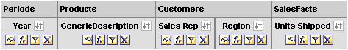
- Click the Results tab to view your results. Notice that the results are displayed in a long table, which may be difficult to manage.
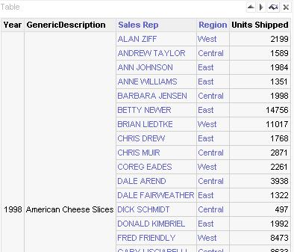
- Create a pivot table to easily manage this data.
  - Click the Pivot Table button. It may take a few moments for the results to display.
  - In order to not have the pivot table refresh every time you make a change, deselect Display Results.
- Customize the pivot table.
  - Drag Year and Region to the Pages section.
  - Drag Generic Description to the Columns section. Make sure that Generic Description is below Measure Labels.
  - Your results should look like this:
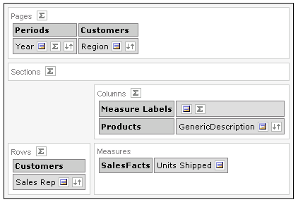
- Click the Display Results link to preview your results. Notice that Year and Region are available in the same drop-down list.
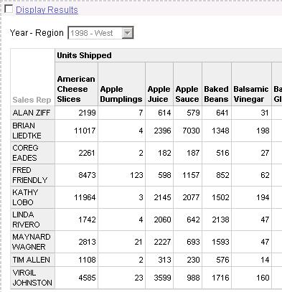
- Set your pivot table so that you can view Year and Region in separate drop-down lists.
  - Click the More Options icon in Region.
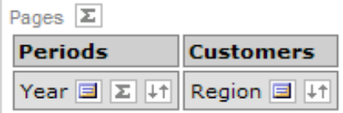
  - Select Start New Page Drop Down.
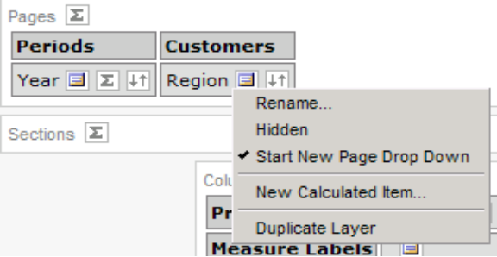
  - Check your results.
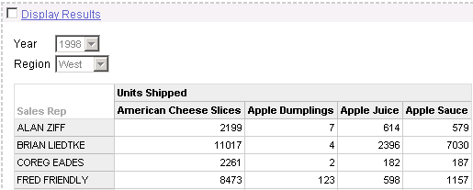
- Click OK. Notice that the original table appears with the new pivot table below it. (Scroll to the right to view the original table).
- Delete the original table view.
  - Scroll all the way to the right.
  - Click the Delete View button for the Table view.
- Limit the products displayed.
  - Click the Criteria tab.
  - Click the Add filter button for the GenericDescription column. The Create/Edit Filter window opens.
  - Change the Operator to begins with.
  - Type A in the Value field.
  - Click OK.
  - Click the Results tab to view the changes.
- Add a chart to the pivot table.
  - Click the Edit View button in the Pivot Table view.
  - Select the Chart Pivoted Results check box at the top of the workspace.
  - Click the Display Results link to preview the chart.
  - Change the Graph to Horizontal Bar.
  - Change the Chart Position to Above.
  - Click the Display Results link to preview the chart.
  - Click OK in the upper right corner.
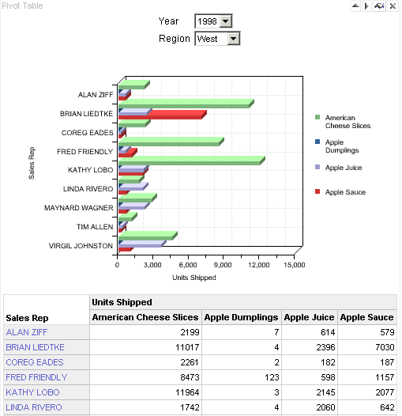
- Save your results.
  - Click the Save button.
  - Save your request in the My Sales folder as My Pivot Table.
  - Click OK.
- Leave Answers open for the next lab.

Lab 2-3 Adding a Column Selector to a Request
Goals | To add a column selector to a request
Scenario | You need to add a column selector view to allow users to dynamically change which columns appear in a request
Time | 5 – 10 minutes
Instructions
- Click the Answers link to clear the workspace and return to the Answers start page.
- Click the SupplierSales subject area.
- Create the following request:
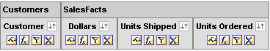
- Click the Results tab to view your results. By default, the results appear in a compound layout with a title view and a table view.
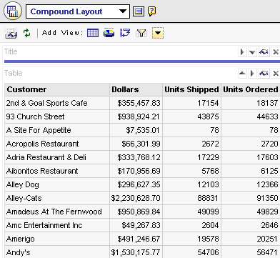
- Add a Column Selector view to the Compound Layout view.
  - Click the Add View link and select Column Selector from the list.
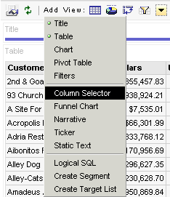
  - In the Column 0 column (Customer), select the Include Selector option.
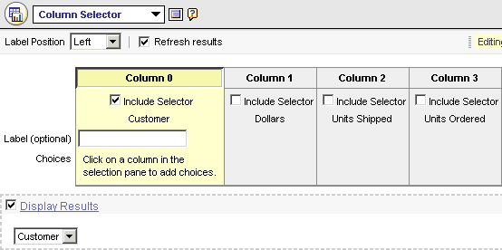
  - Add choices to the column selector by clicking the following columns in the selection pane: Periods.Month, Periods.Year, Customers.Region, Customers.State.
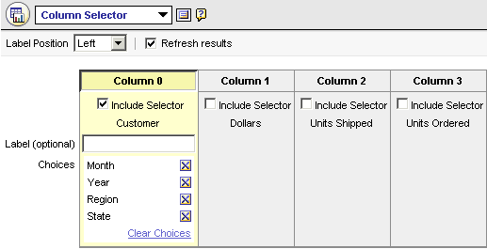
  - Click OK to return to the compound layout view.
  - Scroll to the bottom and locate the Column Selector view.
  - Click the Up arrow to move the Column Selector view above Table view.
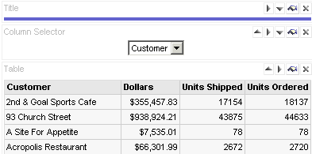
- Use the Column Selector to modify the table results.
  - Select Region from the Column Selector drop-down list and notice the results.
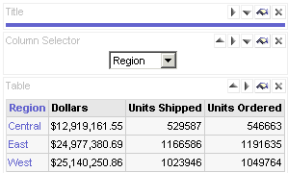
  - Select the other columns from the Column Selector and notice the results.
  - Save your request as My Column Selector.

